WHY CANNY BEST IN CHINA

- The only listed company in stock exchange in China elevator industry
- The first 7m/s super high speed elevator in China brands is developed by Canny independently.
- The first domestic enterprise appraised as “National-Level Enterprise Technical Center” in China’s elevator industry
- For 9 years, the economic index of Canny is the first place among elevator industry
- Establish the first “Academician Workstation” in elevator industry
- Establish the first bachelor degree elevator academy.
- Biggest industry areas 1412,000 m2. Hitachi 722,000 m2, Schindler 550,000, Toshiba 350,000, Otis 277,000, Shanghai Mitsubishi 273,000, ThyssenKrupp 260, KONE 240,000 m2.
- Canny has a complete industrial chain including the design and production of complete elevator & escalator, key parts and other parts. Till now, Canny’s self-production for elevator has reached more than 80%, for escalator is more than 50%, and the number will be increased continuously.
- Advanced production equipment: Canny invested two Salvagnini flexible production lines imported from Italy. It is the most advanced automatic production equipment in elevator industry. Canny also bought industrial robot, painting line, digital machine tool, electronic dust-free workshop etc., which make up the top-ranking production system with high production efficiencies.

- Production Capacity:
Canny has complete production capacity, products category is abundant, especially the production capacity of escalator.

Company name | Elevator | Escalator
Canny | - Passenger lift V≤8.0m/s  - MRL Passenger lift V≤2.0m/s  - Panorama lift V≤2.0m/s  - Hospital lift V≤2.0m/s  - Freight lift Q≤5000kg  - Car lift Q≤4000kg  - MRL freight lift Q≤4000kg  - Hydraulic freight lift Q≤6000kg  - Dumbwaiter lift Q≤250kg | - Escalator H≤36.0m  - Moving walk≤118.32m
Giant KONE | - Passenger lift V≤4.0m/s  - MRL Passenger lift V≤1.75m/s  - Panorama lift V≤2.0m/s  - Hospital lift V≤3.0m/s  - Freight lift Q≤5000kg  - Car lift Q≤2000kg  - Hydraulic passenger lift V≤0.5m/s  - Hydraulic freight lift Q≤7000kg  - Firemen lift V≤3.0m/s | - Escalator H≤26.4m  - Moving walk≤50.0m
Shanghai Mitsubishi | - Passenger lift V≤8.0m/s  - MRL Passenger lift V≤1.75m/s  - Panorama lift V≤4.0 m/s  - Hospital lift V≤2.0 m/s  - Traction type Freight lift Q≤7000kg  - Car lift Q≤3200kg  - MRL freight lift Q≤3000kg  - Hydraulic passenger lift V≤1.0m/s  - Hydraulic freight lift Q≤5000kg  - Dumbwaiter lift Q≤500kg  - Firemen lift V≤4.0m/s | - Escalator H≤24.12m  - Moving walk≤97.08m
Hitachi China | - Passenger lift V≤10.0m/s  - MRL Passenger lift V≤2.5m/s  - Panorama lift V≤6.0m/s  - Hospital lift V≤2.5m/s  - Traction type Freight lift Q≤5000kg  - MRL freight lift Q≤2000kg  - car lift V≤3300kg  - Dumbwaiter lift Q≤300kg  - Firemen lift V≤2.5m/s | - Escalator H≤26.4m  - Moving walk≤54.36m
KONE China | - Passenger lift V≤10.0m/s  - MRL Passenger lift V≤2.5m/s  - Panorama lift V≤3.5m/s  - Hospital lift V≤6.0m/s  - Traction type Freight lift Q≤6000kg  - MRL freight lift Q≤5000kg  - car lift V≤5000kg  - Firemen lift V≤6.0m/s | - Escalator H≤40.2m  - Moving walk≤118.32m

- In November 2013, CANNY ELEVATOR was awarded by the second ”NATIONAL CONSTRUCTION MACHINERY AND ELEVATOR GOLDEN QUALITY”.

- Escalator Patents Number in China:

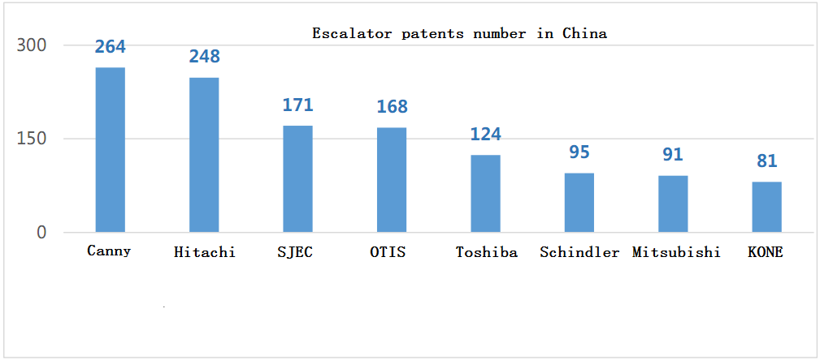

- CANNY testing tower, the highest tower in the world. In March, 2013, the main height structure of testing town is 288 M (above ground 268 M), and it was laid a foundation in Industrial development zone. The new testing town has 9 shafts; there are 8 testing shafts, 1 for panoramic shaft and 1 for escalator testing platform. It can be tested the highest speed of super-high speed elevator 21m/s, the maxima height of escalator is 50M. The testing tower will be finished in the end of the 2015; it will refresh the maxima height and the super high speed record.

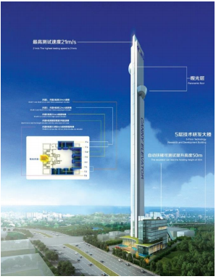

NO | Enterprise | Height (M)
1 | CANNY ELEVATOR | 268
2 | THYSSENKRUPP | 248
3 | KONE | 236
4 | XIO LIFT | 190
5 | HITACHI | 173
6 | BLT ELEVATOR | 177
7 | FUJITEC | 152
8 | SJEC | 140
9 | Toshiba | 130
10 | SSL | 128
11 | SHANGHAI Mitsubishi | 110
12 | OTIS | 115
13 | GIANT KONE | 88
14 | Yungtay ELEVATOR | 80
15 | Schindler ELEVATOR | 72

Note: KONE has built 300 meters in Finland, It belongs to underground installation, we don’t add it.

- CANNY has built agent sales and service network in 49 countries, and export escalators and elevators to 100 countries and areas. The hot areas: Russian, South Korea, India, Mongolia, Bangladesh, Malaysia, Indonesia, Iran, Azerbaijan, South America and so on.

- Honors: (2005-2013)”The No1 of quantity of sale similar products in China market” 9 years in a row.
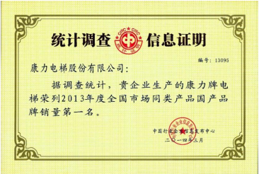
- ”The most satisfied product in China”, ”users most satisfied unit”
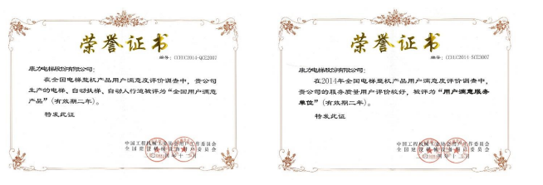
- (2013-2015)”500 tops of developers’ first choice elevator supplier”

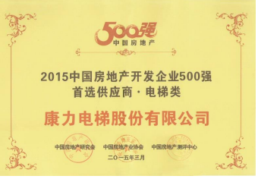

- Canny elevator (2013-2015) 3 years continuously listed in “preferred supplier brand of TOP.

VII. Classical projects

- The listed 4 kinds of projects represent the highest market of escalator and elevator.
- High speed elevator(with 3m/s over than 300 units; 4m/s over than 120 units; 6m/s over than 25 units)
6m/s: Shanghai Longement Yes tower, Shenyang Longement, Chengdu Longement..
4m/s: Century Gold-source Hotel in Guiyang, Luoyuanwan, Fuzhou, Hefei, Guian, Hangzhouwan; Heyin square in Guangzhou, Suzhou Metro control building, Shanghai Longement Yes tower, Shengyang Longement, Chengdu Longement.

- Public transportation (including over than 2,000 units heavy duty public escalators)
Suzhou Metro Line 1/ Line 2/ Line 4 (whole line), Changsha metro Line 1, Guangdong high speed railway, Dalian Interurban railway, Shanxi high-speed railway, Beijing-Shanghai high speed railway Wuxi station, Harbin metro Line 1, Nanchang international airport, Korea metro, India metro, India railway, Iran metro, Iran railway, Turkey metro, Zhangjiajie Tianmen mountain, and other high-speed railway projects.

Special instruction

- Chongqing Empark hotel: the earliest Chinese brand elevator with high speed 3m/s in year 2005
- Guiyang Empark grand hotel: the earliest Chinese brand elevator with high speed 4m/s in year 2008
- Shanghai Longement YES tower: the earliest Chinese brand elevator with high speed 6m/s in year 2011(actual speed can reach to 7m/s), together with Shenyang Longement project, keep the record of Chinese brand fastest elevator(with actual project)
- Guiyang century complex: purchase elevators and escalators over 1350 units, one of the biggest complex in the world.
- Chengdu New Century global center: the biggest individual building in the world, the most influential project In Chengdu area, Canny offer 161 units elevators, 142 units escalators, among which there are 2 units escalators with 21m high escalators, magnificent and resplendent, especially noticeable.
- Chongqing International EXPO center: the biggest in the west of China, the 2nd biggest in China professional stadium, Canny offer 162 units elevator and 16 units escalators.
- Chongqing ChaoTianMen international trade center: Midwest imports and exports distributing center, Canny provided to this project 125 units elevators, 133 units escalators.
- Hebei Tatan international trade center: The biggest complex in Hebei province, Canny provided 342 units escalator for this project.

- Guiyang southwest trade center: The biggest trade & logistics center in China, Canny provided 80 units elevators and 127 units escalators.
- Foshan international home furnishing center: the biggest home furnishing center in the world, Canny provide 44 units elevators and 138 units escalators.
- Wanda Square: Canny is listed in the supplier of Wanda group, together with Hitachi and Shanghai Mitsubishi.
- Suzhou metro, in year 2008 win the tender of Suzhou metro line 1, it is the first time that Chinese brand win the domestic metro project; after that, win the Suzhou metro line2 in year 2012, line 4 in year 2014. Line 3 is not started to construct yet.
- Korea Metro: from year 2006, the first time Canny serve Korea metro, every year has order, totally provide heavy duty escalators more than 700 units, Canny is one of the main supplier of metro of South Korea.
- India metro/railway: year 2012-2013, Canny elevator win the bid of Indian railway station 52 units, New Delhi metro 295 units heavy duty public traffic escalators. Canny products stand the test of continuous high temperature and high flow wicked environment.
- Zhangjiajie Tianmen mountain sightseeing tunnel, the project is to difficult that the international brands don’t dare to participate, Canny elevator finish it perfectly, get the awards of first prize of American famous <Elevator World> in “ The world engineer prize”, it’s the first time that Chinese brand win this prize.

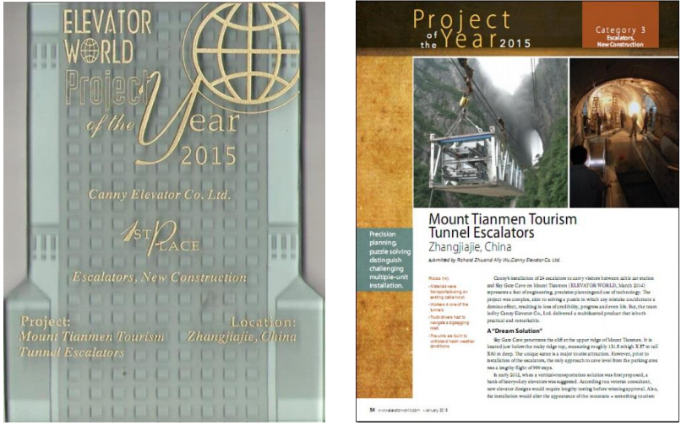

- Comparing with 8 international brands, Canny has enough high level project, which states Canny has the capability to compete with international brands in same level:

High speed elevator field: Canny high speed elevator represent the highest level of Chinese brand elevator industry, the technique and service is tested by market:
Chongqing Empark hotel, 3m/s elevators have been safety running over 10 years
Guiyang Empark grand hotel, 4/s elevators have been safety running for 6 years
Shanghai Longement YES tower super high speed elevator with 6m/s, safety running nearly 4 years

Public transportation field: Canny heavy duty escalators represent the highest level of Chinese brand escalator industry, strong power in the production, many classical projects( the project numbers is much more than Toshiba, Escalators projects number is similar like Kone, Shanghai Mitsubishi, Fujitec), technique is mature, cost performance is high, service reaction is fast, the running state and public praise is good.
Korea metro escalators have been safety running nearly 9 years
Suzhou metro line 1, 199 units have been safety running 4 years.
Suzhou metro line 2, 315 units have been safety running 3 years.
ZhangJiajie Tianmen Mountain sightseeing tunnel escalators, 24 units KLXF have been safety running 2 years.

Complex field: Complex project request various kinds of elevators and escalators, tight delivery time, strong supply strength and high level engineer management.
Canny has complete production lines, no short slab, various kinds of decoration, can satisfy many kinds of request from clients, cooperate with famous real estate enterprise, and has good project management experience and good praise from clients.
Five-star hotel field: Five-star hotel has higher request to the elevator and escalator’s brand, decoration, running efficiency, safety, steady and service.

Canny has many classical project, good project experience, mature products technique, combine with new type luxurious cabin decoration, KLK1 golden swallow high level passenger elevator, KLK2 golden Leopard high level high speed elevator, which help Canny has strong competitiveness in this field.

